**Question No: 01**

**(a) Define multimedia system and multimedia presentation. Write the key properties of a multimedia system. 3.5**

**Ans:**

**Multimedia system:**

A **Multimedia System** is a system capable of processing multimedia data and applications. A **Multimedia System** is characterized by the processing, storage, generation, manipulation and rendition of Multimedia information.

**Multimedia presentation:** A multimedia presentation differs from a normal presentation in that it contains some form of animation or media. Typically a multimedia presentation contains at least one of the following elements:

* Video or movie clip
* Animation
* Sound (this could be a voice-over, background music or sound clips)

Navigation structure

**Key properties of a multimedia system:**

* Discrete and continuous media
  + Support of one type does not constitute multimedia
* Independent media
  + The media used in a MM system should be independent.
* Computer-controlled systems
  + We need a system capable of processing media in a computer-controlled way.
* Integration
  + Independent media streams can be integrated to form a global system.

**(b) What is font? Distinguish between postscript and true type font. 3**

**Ans:**

**Font:** A font is a collection of characters of a single size & style, belong to a typeface family

* + Typical font *styles* are boldface, italic, bold italic, and underlined

**Postscript Font:**

PostScript fonts were created by Adobe. They have two different parts, one that contains information for printing, and the other that's used to display the font on the screen. PostScript fonts make it possible for really high quality printing. A drawback to them is that they're not cross-compatible, so there are different versions for Macs and PCs. PostScript fonts are also often referred to as Type 1 Fonts. Since the creating of OpenType fonts, the use of PostScript fonts has dwindled significantly.

**True type font:**

TrueType is a font format that was developed by Apple and was eventually licensed to Microsoft. They only require one file, but a separate file needs to be added for each instance of the font. Which means you'll need a different file for normal, italic, bold, bold italic, etc. TrueType typefaces are usually used in a business office since they can be a little unreliable for publishing. TrueType fonts work well with Microsoft Office. For a while TrueType fonts worked really well with PostScript fonts, meaning that the TrueType fonts would be used for screens, and PostScript for printing purposes.

**© Write the common data encoding schemes for text with example. 2.25**

**Ans:**

* + **Code:** Code is a list of symbols (letters, numbers, bits etc.).
  + **Code word:** Code word is a sequence of symbols used to represent a piece of information or an event (e.g., gray levels).
  + **Code word length:** Code word length is the number of symbols in each code word. 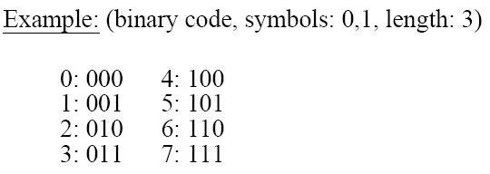

**Question No: 02**

**(a) Write the importance and drawbacks of digital representation of the signal. 3**

**Ans:**

**Importance of digital representation:**

* More options and flexibility in terms of recording and reviewing media.
* More options in terms of being able to manipulate what is recorded.
* More options being able to share media both socially and for business.
* Much less bulky than analogue equivalent.
* Recorded media is more durable.

**Drawbacks of digital representation:**

* It’s more complex so there’s more to go wrong.
* It’s unforgiving if the data is damaged, tends to spoil the whole media packet. E.g. TV if too much data is lost the whole image freezes and scrambled.
* Harder to fix when it does go wrong.
* More expensive to fix when it goes wrong.

**(b) What is coding? Briefly discuss the lossless predictive coding scheme. 4.75**

**Ans:**

**Coding:** Coding of multimedia information is subject to certain quality constraints. For example, the quality of a picture should be the same when coded and, later on, decoded.

**Lossless predictive coding:**

Lossless predictive coding does not require decomposition of an image into a collection of bit planes. It is based on eliminating the inter-pixel redundancies closely spaced pixels by extracting and code only the new information in each pixel.

- New information: the difference between the actual and predicted value of that pixel.

The coding system consists of an encoder and a decoder, each contains an identical predictor.

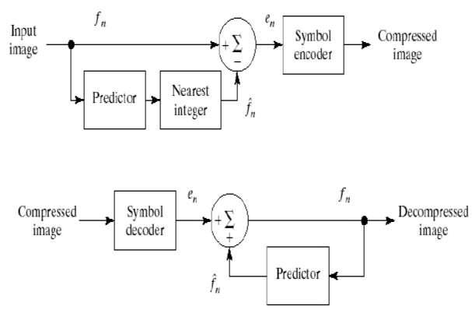

* The predictor generates the anticipated value of that pixel based on some number of past inputs.
* Form the difference or predictor en, which is coded using a variable-length code to generate the next element of the compressed data stream.
* Generate *fn* based on global, local and adaptive



* In 1D linear prediction f(x , y) is a function of the previous pixels on the current line alone.
* In 2D predictive coding, the prediction is a function of the previous pixel in a left -to-right, top-to-bottom scan of an image.
* In 3D case, it is based on the pixels and the previous pixels of preceding frames.

**© How many bytes are required to record a 16 bit CD quality stereo audio per minute? 1**

**Ans:**

Here,

sample rate = 44.1 kHz

sample size=16 bit

time=1 min

We know,

File size= (sample rate* sample size* time)*2

= (44.1 kHz * 16 bit * 1 min)*2

= (44100 Hz * 16 bit * 60 sec)*2

=84672000 bits

=10.09 MB.

**Question No: 03**

**(a) Distinguish between lossless and lossy Data compression. Why data compression is important in multimedia system? 3**

**Ans:**

**Importance of data compression:**

Compression in computer terms means reducing the physical size of data such that it occupies less storage space and memory, Compressed files are, therefore, easier to transfer because there is a sizable amount of reduction in the size of data to be transferred.

**Lossless vs Lossy Compression:**

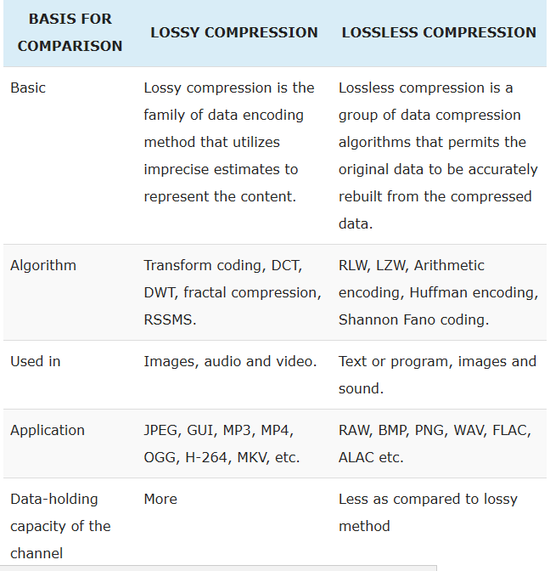

**(b) Define entropy of an information source with alphabet S= {s1, s2, s3, … , sn} ? 1**

**Ans:**

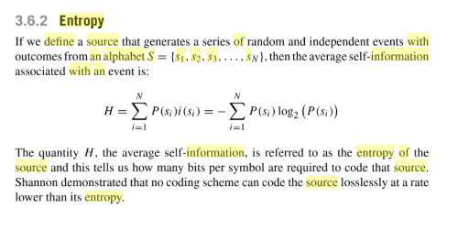

**© Explain one of the entropy coding methods for lossless compression with example. 4.75**

**Ans:**

**Question No: 04**

**(a) “JPEG compression is largely based on some observations”. State those observations. 3**

**Ans:**

JPEG uses *transform coding*, it is largely based on the following observations:

**Observation 1:** A large majority of useful image contents change relatively slowly across images, i.e., it is unusual for intensity values to alter up and down several times in a small area. Translate this into the spatial frequency domain, it says that, generally, lower spatial frequency components contain more information than the high frequency components which often correspond to less useful details and noises.

**Observation 2:** Humans are more receptive to the loss of higher spatial frequency components than the loss of lower frequency components.

**(b) Explain the progressive mode in JPEG compression. 4**

**Ans:**

A progressive JPEG is an image created using compression algorithms that load the image in successive waves until the entire image is downloaded. This makes the image appear to load faster, as it loads the whole image in progressive waves. A normal JPEG loads the image from the top to bottom line by line.

**© Define the 2D Discrete Cosine Transformation (DCT). 1.75**

**Ans:**

Discrete Cosine Transform is a technique applied to image pixels in spatial domain in order to transform them into a frequency domain in which redundancy can be identified.

In JPEG compression, image is divided into 8×8 blocks, then the two-dimensional Discrete Cosine Transform (DCT) is applied to each of these 8×8 blocks. In JPEG decompression, the Inverse Discrete Cosine Transform (IDCT) is applied to the 8×8 DCT coefficient blocks. DCT and IDCT are defined as follows: DCT: [[https://static-content.springer.com/image/prt%3A978-0-387-30038-2%2F4/978-0-387-30038-2_4_Part_IEq3_HTML.gif](https://static-content.springer.com/image/prt:978-0-387-30038-2/4/978-0-387-30038-2_4_Part_IEq3_HTML.gif)](https://static-content.springer.com/image/prt%3A978-0-387-30038-2%2F4/978-0-387-30038-2_4_Part_IEq3_HTML.gif)